2026
Jaleel Wayne Le Grancie st10539066
Rochelle’s Dress Makers Pty
11/08/2026
Rochelle’s dressMaker pty ltd
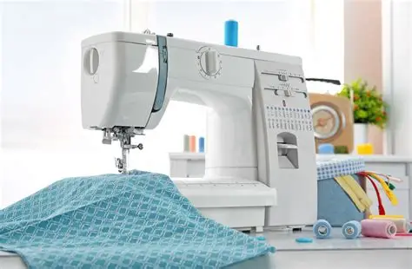

Contents
1.Organisation overview 2
2.Website goals and objectives 2
3.Current website analysis 2
4.Proposed Website features and functionality 2
5.Design and user Expierence 3
6.technical requirements 3
7.Timeline and milestones 3
8.Budget 3
9.Referencing 3

1.Organisation overview
- Name: Rochelle’s dressMaker pty ltd
- Brief history of the orginsation: This organization started back in the year 2000 , a young lady fell in love with making wedding dress, banquet dresses, and sitting behind he sewing machine. She inherited this gift from her mother who taught her everything she knows today , she makes banquet dress and blessers those that are unable to afford it. Her business is based at her home where she find more comfort. She spends most her time behind her machine altering and sewing something new with her brain that thinks of something new every second.
- Mission and video statement: Love others as you love yourself.
- Target audience: People who love working with their hands , people who are great at sewing people with an outgoing personality great ideas and a joyfull spirit.

2.Website goals and objectives
- Promote Rochelles business to reach a wider audience , make her company known so people who are interested can know what she offers and what her company offers
- Success is measured to how many milestones you have reached over your short/long term goals

3.Current website analysis
- Ana
- Identify

4.Proposed Website features and functionality
Each page would have its own background colour to outline different ideas and different perspective. Each page would have a detailed outline on what the business is all about , give you insight into where she is based and more of the work she has done , images to represent her style of work.

5.Design and user Expierence
- Color scheme: Pink , purple and green
- Typograpy: Apos
- Layout and design: colorful designs to represent creativity , also to highlight women nature

6.technical requirements
- Html

7.Timeline and milestones
Within the next year she will own her very own factory and have up to 100+ sewing machines with enough crafted workers that can do a wonderful job.

8.Budget
- 150000 for factory and material
- 20000 for sewing machine
- Partnership with clothing material brands etc.

9.Referencing
• Sew Much Better (2026) Sewing made easy: Your sewing, embroidery & wool specialists. Sew Much Better, Johannesburg. Available at: https://sewmuchbetter.co.za/ (sewmuchbetter.co.za in Bing) [Accessed 11 August 2026].
• Goley Style Shop (2026) Women’s bespoke tailoring & design services. Goley Style Shop, Johannesburg. Available at: https://goleystyleshop.co.za/ (goleystyleshop.co.za in Bing) [Accessed 11 August 2026].
• Snupit (2026) Best dressmakers in Johannesburg. Snupit. Available at: https://www.snupit.co.za/johannesburg/dressmakers (snupit.co.za in Bing) [Accessed 11 August 2026].
• Talitah Bridal Couture (2026) Bridal couture fashion house. Talitah Bridal Couture, Johannesburg. Available at: https://talitahbridalcouture.co.za/ (talitahbridalcouture.co.za in Bing) [Accessed 11 August 2026].
• Onyx Couture (2026) Custom couture dresses and bridal gowns. Onyx Couture, Johannesburg. Available at: https://onyxcouture.co.za/ (onyxcouture.co.za in Bing) [Accessed 11 August 2026].

